WP4: PILOT ACTIONS

Pilot Activity D.T.1.4.3.
Terms of Reference

Contents
1. Introduction 3
2. Pilot action description 4
Proof of Concept phase 5
Foundation phase 6
Incident phase 7
Analytics phase 9
Ship database phase 10
Future expansion 12
3. Delivery of HW components - HW and SW for data capturing and optimization 14

Introduction

Port of Ploče Authority as public body and administrative body within Port of Ploče permanently rising safety in port area and aims to improve and speed up port procedures within logistic chain. Port procedures are focused on ship arrival/departure procedures, Cargo manipulation within port area, custom and logistic procedures, gate in/out procedures and safety procedures within port areas.
Port of Ploče Authority has developed Port Community System which is used by port stakeholders and all procedures are covered within system. Port Community System has been integrated with subsystems which are used for access control and subsystem for Control and management of vehicles which enters or leave port area.
For Port of Ploče Authority one of the main bottlenecks is lack of integrated information systems and low exchange data with other system which are existing in port areas which have impact on cargo transport by sea and land side and entrance terminal to port area. This bottleneck is not bound to infrastructural improvement, but also to an organizational/management solution.
Port Community System which is integrated with other subsystem controlled by Port of Ploče Authority is constantly upgraded in order to achieve harmonized, stable and reliable electronic platform for fast and safe exchange of data between all relevant stakeholders including shipping industry and port operators.
In order to further improve data exchange between port users Port of Ploče Authority identified the needs to develop and upgrade PCS system modules used between port agencies and security authorities for the automatize secured exchange of authorized gate in/on data regarding vehicles entering port terminals and to analyse actions and needs for data exchange in maritime part regarding ship arrival and departure procedure in a way to have new technological improved control centre to cover Visualization of vessel traffic and port infrastructure in GIS, Inbound/outbound handling and incidents with forms and checklists and Administration of the own resources with use of an automated log and Legal proof recording and incident analysis.
With aim to upgrade and develop system for better control and management in all areas, pilot actions will be focused n ship arrival/departure procedures and gate in/out procedures covered within Entrance Terminal. One of focused activity will be regarding integration with AIS Base Stations and Traffic Image Application for the VTS Centre and SAR MRSC operations of Port of Ploče Authority. Also, Port of Ploče Authority will focus on providing development of local systems as critical environment following national laws and according to development of National systems developed on National level for all Croatian ports.

Pilot action description
Primary focus of Port of Ploce Authority within project is to develop ICT solutions as upgrade of existing ICT solution which are existing in Port of Ploče area with aim to solve defined bottlenecks in port areas. With aim to upgrade and develop system for better control and management in all areas, with focus on ship arrival/departure procedures, Port of Ploče Authority will lower bottlenecks in transport and services regarding multimodality in the Adriatic-Ionian area. Data capturing will be focused on capturing data relevant for ship arrival/departure procedures,
Port Community System exchange functionalities regarding integration with AIS Base Stations and Traffic Image Application for the VTS Centre and SAR MRSC operations of Port of Ploče Authority have been agreed between the MMPI and Port of Ploče Authority after which Port of Ploče Authority will finish technical documents regarding integration as prerequisite for procurement activities.
With integration of all needed data mention earlier all relevant information and data captured from stations and based on data feed exchanged from national system will be exchanged through Port Community System which will have impact on solving bottlenecks in port area.
The goal of the pilot actions is to develop IT-system which will have positive impact on port operations based on identified bottleneck processes. Additionally, the outcome must contain improvement of ICT solutions that can be used as prerequisites in the requirements engineering process for the purchase of AIS Base Stations and a Traffic Image Application (application for VTS and SAR operations).
The focus pilot actions will be based on defined workflows that involve the use of a Traffic Image Application and AIS data or radar data which must be exchange on National level. The following questions developed pilot system must be able to answer:
- What are the workflows, that are supported using AIS data and a Traffic Image Application now or can be supported in the future?
- Where are the bottleneck processes that can be solved by the implementation of better IT solutions in context of AIS and a Traffic Image Application?
- How can an improved use of AIS data and data exchange lead to increase maritime safety within the port area and the Ploče VTS/SAR area?
- What are the main optimum Traffic Image Application requirements for the operations at the Port of Ploče in general (in consideration of international regulations SAR and VTS perspective)?
- What are the requirements for the use of AIS data in different contexts and therefore what are the functional requirements for new AIS Base Stations?
- To what extent are the defined requirements future proof and considering current developments in the maritime business?
- What is critical information?
- How data can be exchanged on local level and to other existing systems?
- How to exchange data regarding cargo delivered by ships, manipulated and stored by terminal operators, and controlled by gate in/out procedures when cargo is transported through entrance terminal.
- Subject web service data exchange will be enabled in both directions allowing to push all relevant data within Port community System.

We have defined detailed specification of activities through which should be carried through different phases and different projects regarding ship arrival/departure procedures and processes:
Proof of Concept phase
    - The focus is on demonstrating how the processes of Port of Ploče Authority can be supported within pilot actions based on business processes within port of Ploče area. Within this phase the related backend services (database, servers) will not be installed.
    - The Proof of Concept (PoC) phase will provide the initial demonstrative solution as start concept for pilot actions. The basic elements to be setup include the geographic information system (GIS) component which will allow geographic information to be added to the solution in the future, and the interface for AIS data, which is the first step for the integration of AIS data into the system.
    - A workshop onsite at Port of Ploče Authority should be done, and will provide the requirements for the incident form, GIS development, Data management and AIS interface customization. The incident form development will be important for the later ‘Incident phase’.

Foundation phase
    - The operational use case feature achieved by this phase is the visualization of vessel traffic and port infrastructure in GIS.
    - The focus of this phase is to provide the basic backend services and an enhanced and improved client, already customized to Port of Ploče Authority’s needs, by enhancing the GIS layer tree. The solution within pilot actions will be developed in collaboration with Port of Ploče Authority with the integration of Port of Ploče Authority’s existing AIS data stream. This phase will provide the core functionalities which will be further built on by the next three phases.
    - The foundation phase will provide the core functionality to the system regarding monitoring and tracking ships. The visualization of the maritime ‘Common Operational Picture’ (COP) will be based on S57 standard maritime charts and AIS data. The main elements of the phase are the kick-off meeting, specification workshop and documents, environment setup, integration, development, and testing.
    - The essential features to be delivered include AIS, which will allow for ships to be visualized as tracks within the system, and the S57 maritime charts provide the SOLAS-standard of electronic navigation charts. To enable these features, a decoder interface, GIS layer integration, S57 implementation, an AIS table and AIS receiver interface will be developed.
    - The test, development and productive environments will be stood up. There will be a period of interface and integration testing to ensure that the AIS track data is correctly visualized. Throughout the whole phase, project meetings will be held via Skype to ensure both sides of the project are up to date on the progress of the project.
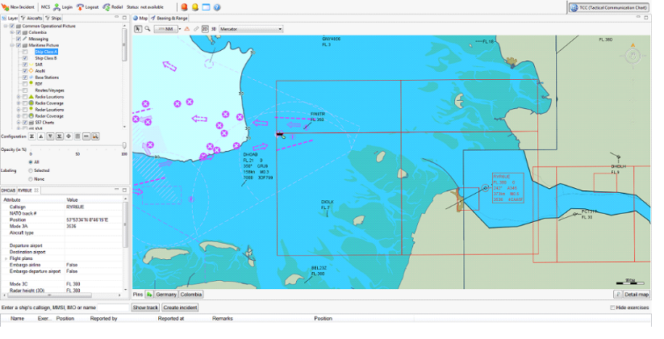
Figure 1 Maritime COP displaying S57 charts and AIS ship tracks

    - At the end of the foundation phase, the system can be used in a productive state for monitoring ships in real time as per SOLAS and IHO standards. The foundation phase consists of the core functionality required for the system to be implemented and used by the customer. Additional phases will introduce more functionality to the system for the improvement of the operations of Port of Ploče Authority.
Incident phase
    - The operational use case features achieved by this phase are the inbound/outbound ship handling, incidents with forms and checklists, and use of an automated log.
    - The focus of this phase is to add incident handling (incident form, checklist, action log) to the AIS visualization. The foundation phase has provided the AIS visualization, and now it will be combined with the incident form customization, to result in a multi-functional solution.
    - The incident phase is a major phase of the overall pilot activities. Until this point, the solution that has been developed enables the monitoring and tracking of vessels. This phase includes the activities required to implement a functional incident management solution in production.
    - The release documentation will need to be provided throughout the project. As part of release management, release notes, impact assessments, and release control procedures will be conducted. Customer release management such as testing, and issue handling will form part of this phase.
    - The System Acceptance Testing (SAT) will occur onsite in Ploče for a three-day period. This testing will be conducted with Port of Ploče Authority to ensure that the requirements of the users have been met. The SAT report will be provided to Port of Ploče Authority.
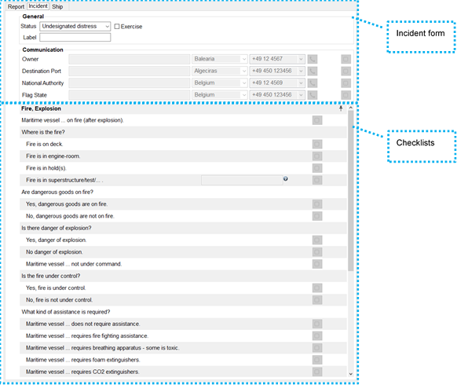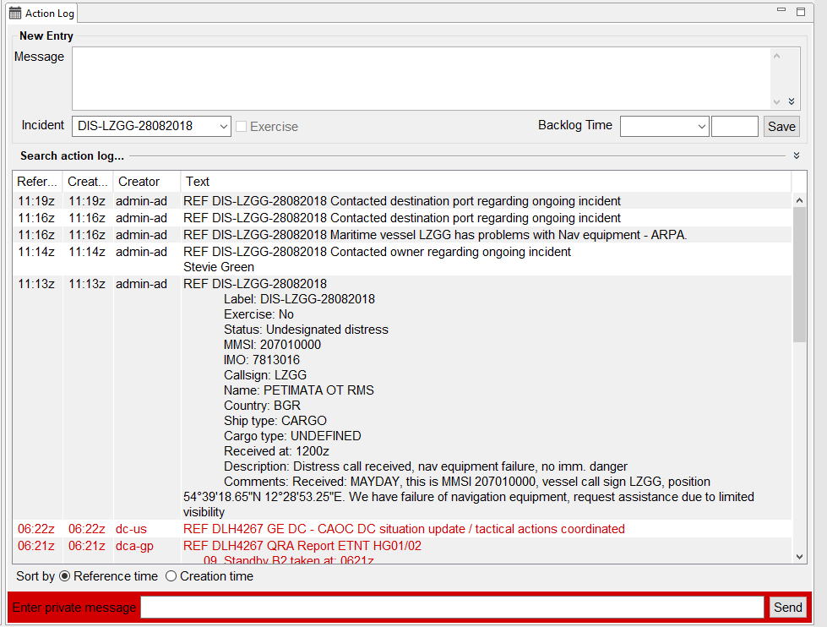
Figure 2 Maritime incident form & checklists (left), and action log (right) during a maritime incident

Analytics phase
    - The operational use case features achieved by this phase are legal proof recording and incident analysis.
    - The focus of this phase is to provide the necessary modules to load historic events and incidents from the database and save them to external files. This phase goes beyond the ‘real time’ monitoring and incident management features. The core features provided in this phase will support operators with post incident attribution processes, as well as the ability to export incident information for training purposes.
    - The analytics phase consists of further development of the solution, such as more advanced S57 GIS feature implementation. The replay functionality is a feature allowing the replay of historic sequences from within the last 30 days. This provides a quick view back in time for incident analysis. The system can record all sensor data in the database and replay it. The analytics component supports the examination and wrap-up phase for incident. Complementing this feature is the use of an oracle database as a central data repository. All data modifications not done by the application will be logged in the audit log module.
    - Project meetings such as project management (PM) meetings will be held during this phase of work. These meetings allow for the managers of both teams to meet in Ploče and discuss the status of the project.

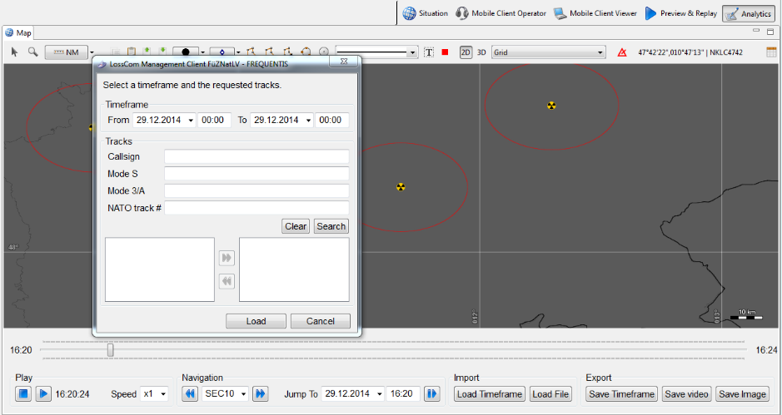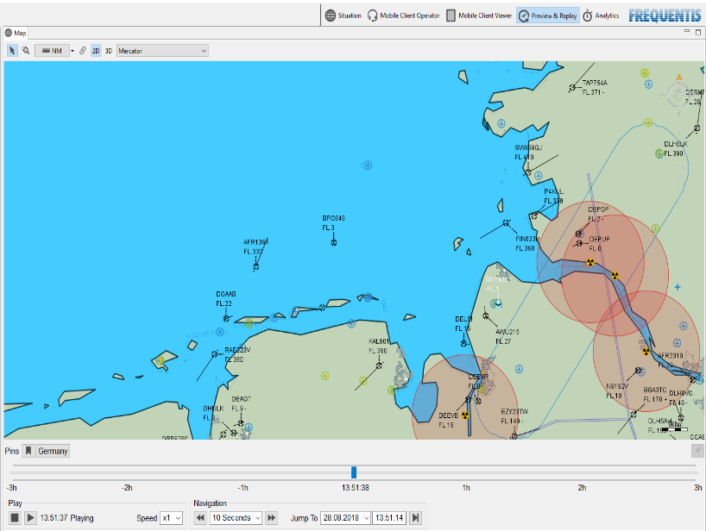
Figure 3 Analytics component of the solution showing the controls
    - The System Qualification Testing (SQT) will take place during this phase. This testing phase will consist of testcases as documented in the test procedure book. The purpose of the qualification testing is to verify the design process.

Ship database phase
    - The operational use case features achieved by this phase are the access to ship information at the touch of a button and administration of the own resources/contacts.
    - The Ship DB’s focus is to create an automatically updated repository of ships, useful for supporting incident management. This phase complements the incident phase to provide operators with reference information during routine and disruptive events. This phase builds on functionality developed in previous phases to result in a more advanced system.
    - The Ship database (DB) phase consists of further feature development, customization and project management activities. The ship database itself will be development along with a user interface. This feature will allow the ship information to be stored.
    - Customization included in this phase is the import of shipowner and contact lists – these are required to populate information in the incident forms for the incident phase of the project. This master data will provide the operator access to important contact information during an incident.
    - As the whole project is underway, the project management activities that will be part of this phase include an onsite project management status meeting, where the progress of the project can be discussed in person at a managerial level.

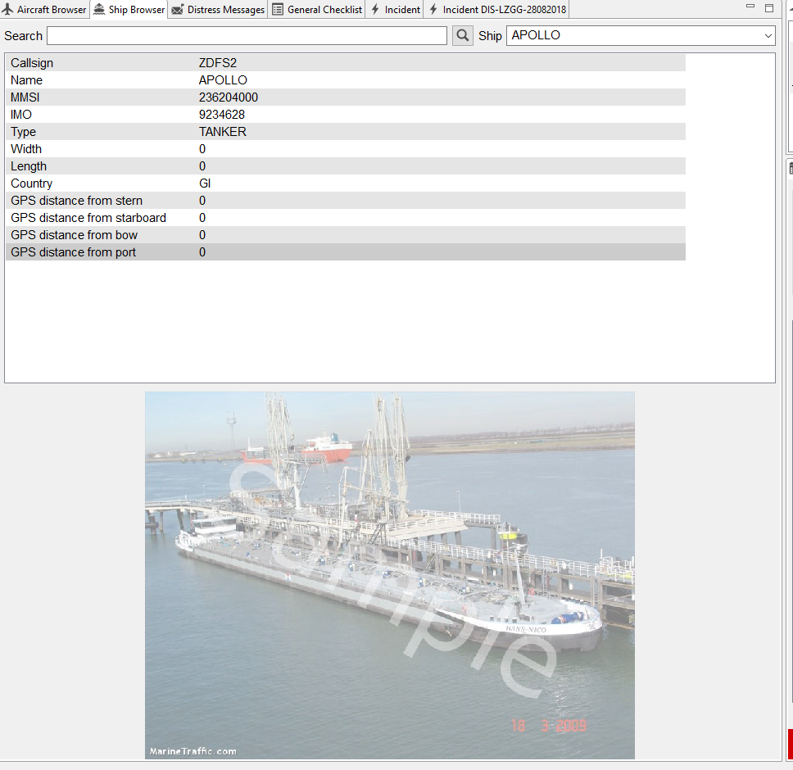
Figure 4 Sample ship information to be available as part of incident management
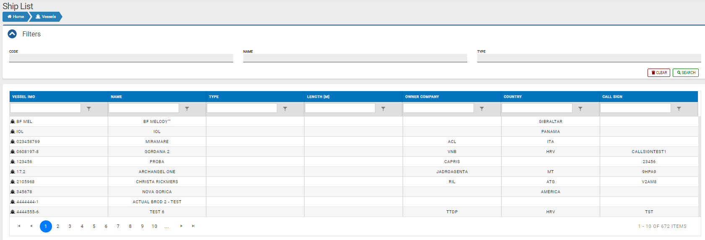
Figure 5 Ship list in PCS which must be exchange based on data captured

Future expansion
    - Pilot system must be upgradable and must be able to expand modules with new functionalities. The future expansion of the solution could include further modules, such as the maritime communication system and its integration, as well as the mobile client, both of which are of interest to Port of Ploče Authority.
    - Mentioned activities will not be carried out only within CHARGE project.
    - Port of Ploče Authority has opened new entrance terminal which is controlled by Control and management system. This system is integrated with Port Community System and for purpose of pilot actions and automatization of the authorization process for vehicle passing to port of Ploče area Port of Ploče Authority will be integrated with Port Community System and will be used for faster and automatized procedures gate in/out procedures.
    - Within Port community System all relevant data regarding maritime and land side on logistics chain will be exchange.
    - Pilot Actions will provide development and upgrade of port systems which are defined as critical systems/subsystems which must operate in critical environment. Because of these aspects, all pilot actions must be done in accordance with national cybersecurity laws which can be applied on critical port environment. Port of Ploče Authority will provide supervision of security aspects of IT infrastructure with the aim of performing technical design of port information systems development and assessment of the level of security of the information system with the aim of performing the technical design of the development of port information systems.

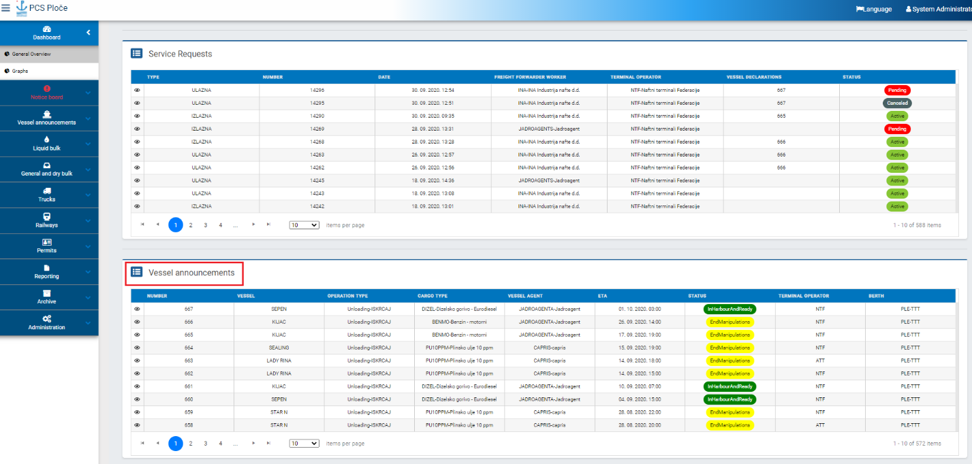
Figure 6 Vessel announcement in PCS based on exchanged data

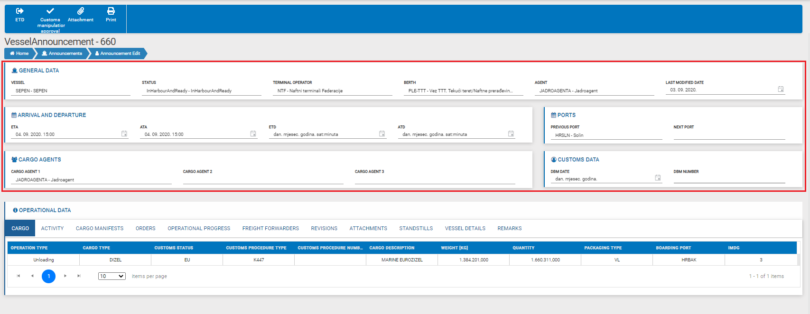
Figure 7 Vessel announcement future exchanged data in red

Delivery of HW components - HW and SW for data capturing and optimization

Port of Ploče Authority has delivered hardware component which will be used for processing data captured in daily operations in port environment. Hardware consists of Servers for data processing and Network communication equipment for data transfer and network security. Servers consists of storage parts for data store which will be used for server virtualization and database software.
Pilot action system will capture data from external sources used for enhancing port security and process data so that could be exchanged.

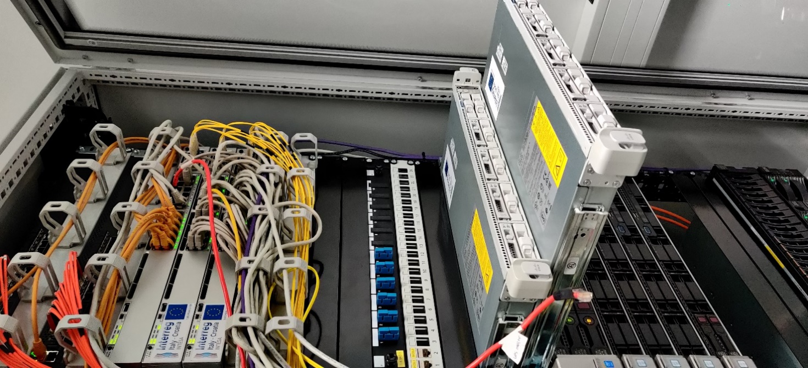
Figure 8 Server and networking equipment in data centar

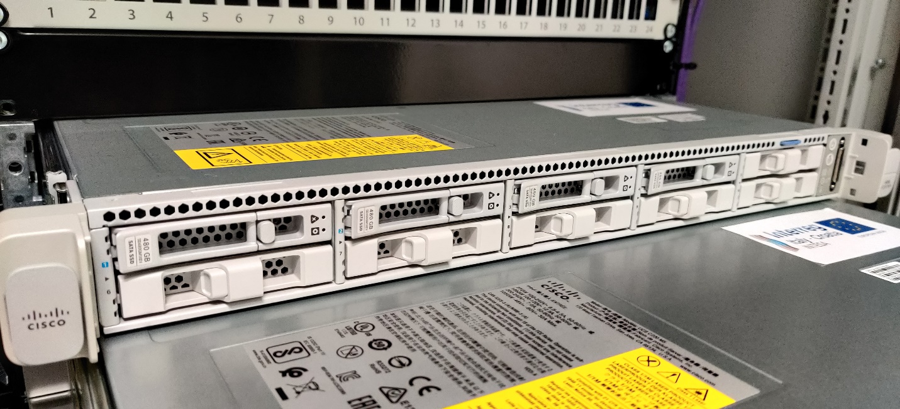
Figure 9 Servers located in rack

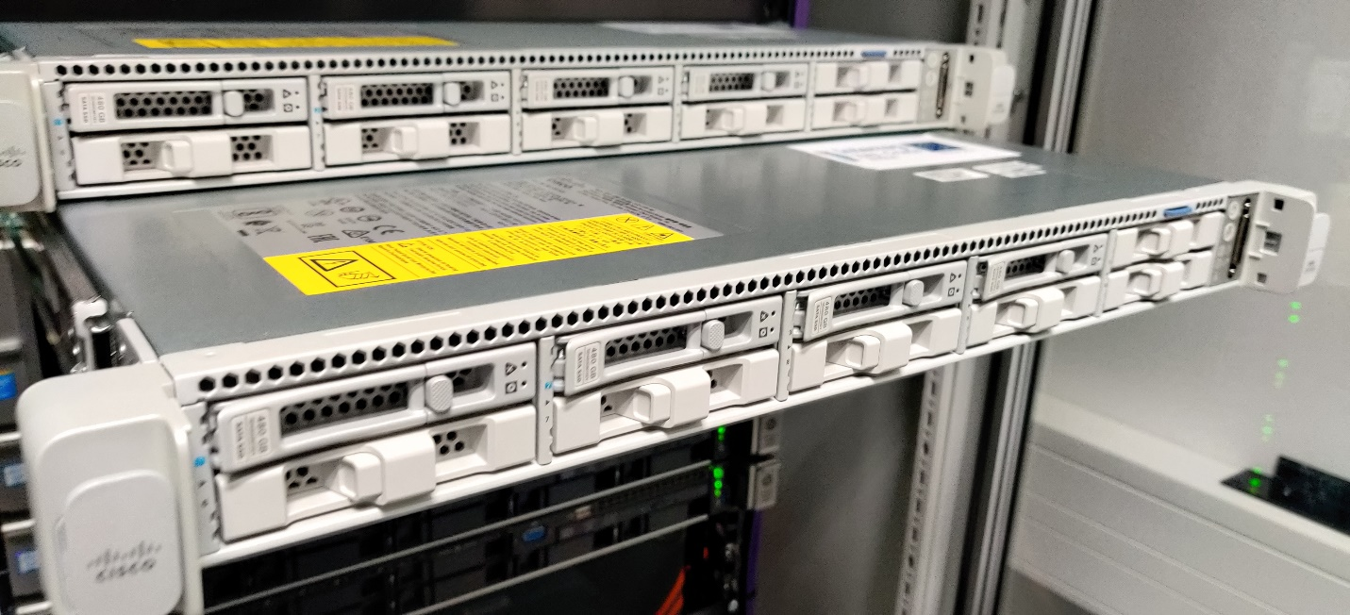
Figure 10 Servers located in rack

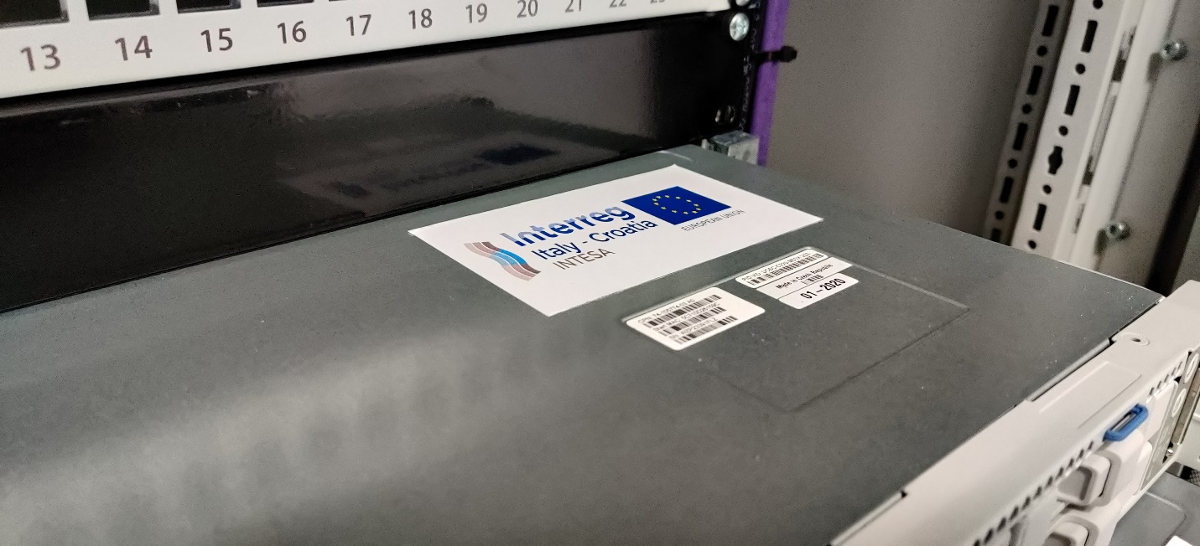
Figure 11 Intesa project visual logo on server 1

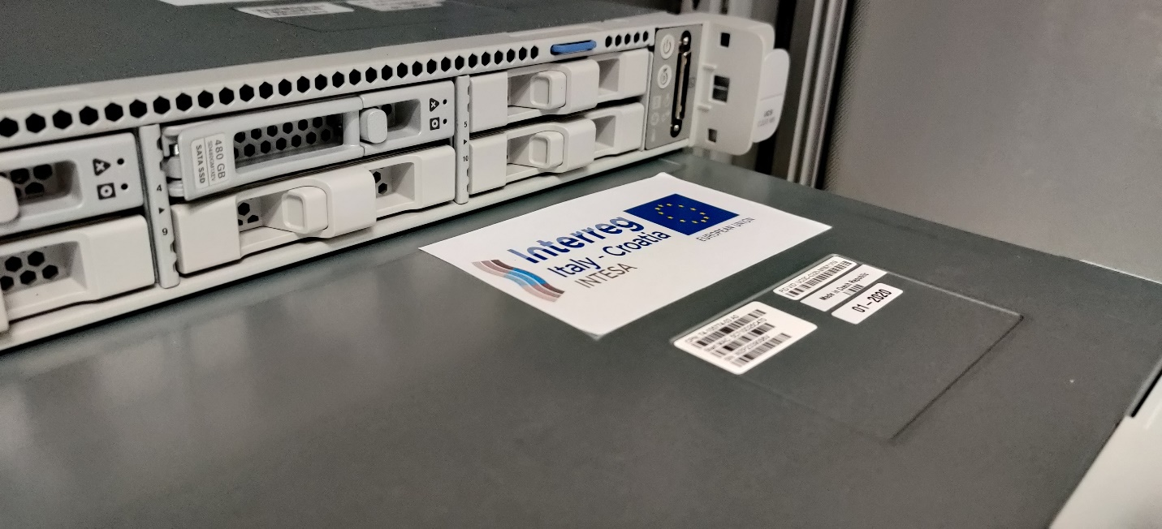
Figure 12 Intesa project visual logo on server 2
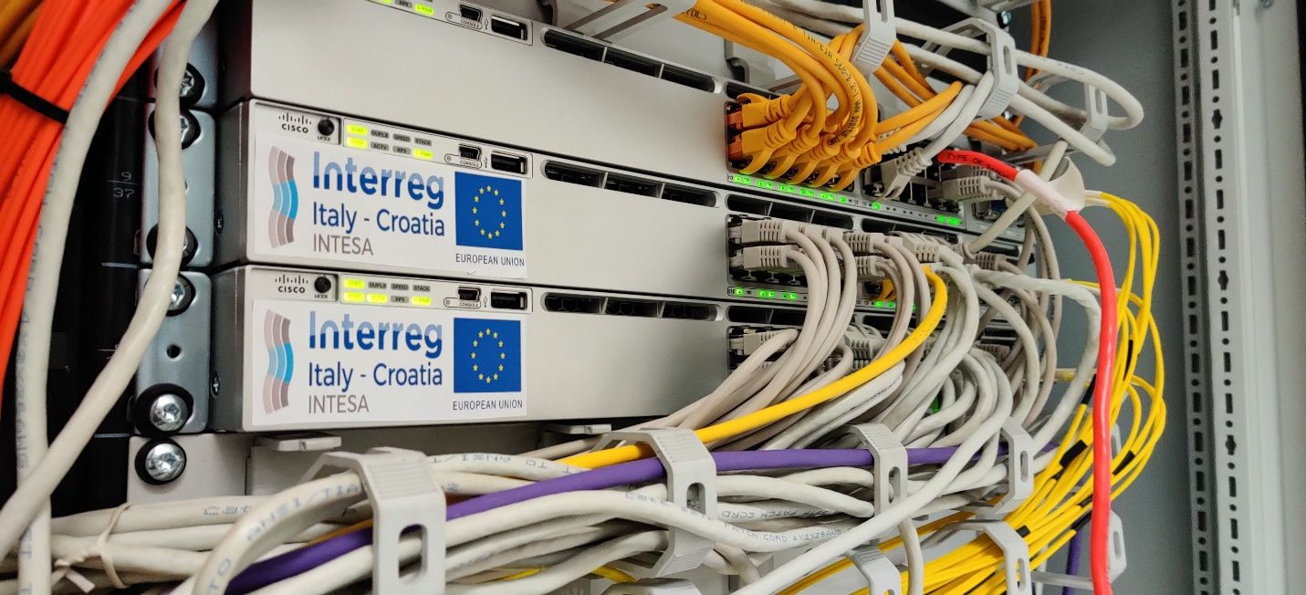
Figure 13 Networking equipment

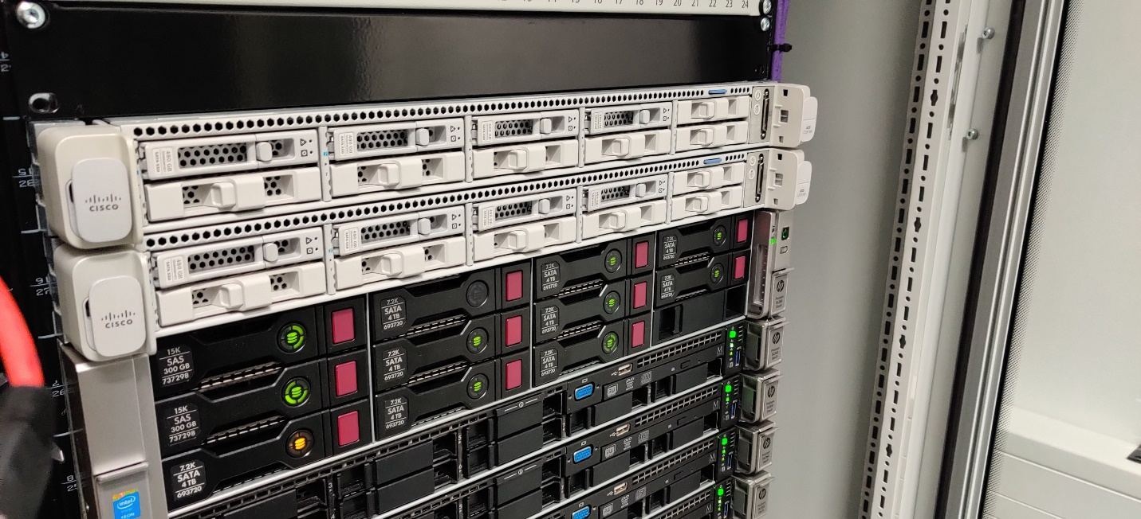
Figure 14 Storage pools

